**Introduction:**

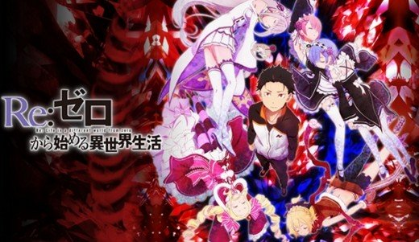

Re:Zero - Starting Life in Another World starts off exactly like it's going to be a painfully cliché, boring, moe piece of shit stereotypical fantasy series. In the first episode, you have the normal human character, being magically transported into a fantasy world, where big surprise, they encounter a magical specimen of the opposite sex. Said magical person helps them navigate the new fantasy world they're stuck in. And she has a cute talking magical animal sidekick. It's all the familiar crap any serious anime fan has seen a million times, right?

Oh, no. Watch more of it, and you soon realize, that you've never seen anything like this before, and that each character has a lot more going on under the surface than their initial illusion of fitting various anime character stereotypes. Part of the fun of this show for me was seeing how unlike you would expect these characters to be based on appearances. The "silly animal sidekick" is mature, parental, and downright pants-peeing terrifying when provoked. The naive Purity Sue princess? She has some kind of hidden connection to the worst evil witch in history, who assumed her identity at one point (or, they may even be the same person, like she has two personalities). The "shy" maid twins (who would be just dumb, jiggling pairs of tits in other anime shows)? They're actually badass monsters with amazing abilities in combat, but are also victims of discrimination, attempted genocide, and ostracism. Most of the characters in this show have hidden layers.

The show is like Spirited Away, in that both stories have an average human being sucked into a fantasy world, where they are woefully weak, useless, and pathetic compared to most people around them. And in both cases, those extreme circumstances push the main character to adapt and get stronger. So, Re:Zero is primarily about Subaru growing and learning. He has to become a supreme badass in a world of badass in order to accomplish his goals of saving Emilia and other characters. And because of the nature of his power, he has to live through a lot of struggles that he can't tell another soul about.

## Plot Summary:

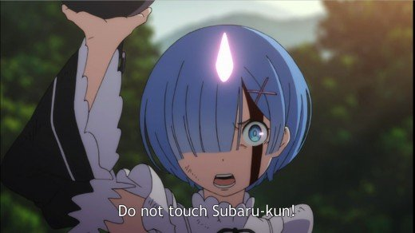

Subaru is at a convenience store but then he's suddenly in another world. The interesting thing is, the person summoning him appears to be himself, dying alongside a girl, of which all we see is her hand. He's suddenly in a large medieval fantasy city that resembles every cliché JRPG or MMO anime. You have elf-people, furry people, lizard-like people, and regular humans, shuffling around and behaving just as you'd expect crowds of people to behave in any large city. He goes to an apple vendor, who tells him to buy something or get lost. Subaru does not have this country's currency, and he doesn't understand their written language (just their spoken language). Asking the apple vendor for help or information doesn't go well. He's wandering around confused when accosted by street urchins. A beautiful girl with silver hair, purple eyes, and elf ears helps him. She has a blunt, pragmatic, tsundere-like personality. She wasn't there to save him, she was looking for a girl who ran past earlier, who stole an insignia from her.

Subaru decides he wants to help her look for that insignia. When they introduce herself, she calls herself Satella. What Subaru doesn't know yet is that Satella is the name of a dreaded legendary evil witch in their universe. This girl will later insist her name is Emilia, and has been all along. Is it a trick, a joke, or does Emilia really have a connection to this fabled evil witch? Satella/Emilia and him help a little girl find her mom. Doesn't sound like something the real Satella would do. She calls herself a half-elf, and looks plainly upset and embarassed by this. Subaru is probably the one person in this world who isn't prejudiced against her for being a half-elf and resembling as such the aforementioned legendary evil witch Satella (this will be an issue that comes up later).

They track down the girl who stole Satella's insignia in the poor side of town. The girl is named Felt. But when they get to the house where they think she's at, Subaru and Satella are killed. Don't worry though, because Subaru wakes up again, back in the past. He's back in front of the apple vendor, before he even met Satella. He tries to go to where they died to find answers. There he meets Rom, an old, tough man, the man he saw killed earlier. He meets Felt, but she won't just hand over the insignia for nothing. He thinks he has her convinced that his flip phone is worth it as a trade, but he then has to contend with the mysterious woman who also wants to negotiate for it - and Felt will give it to whoever pays her the most.

Rom says the cell phone is worth more than the 20 coins promised by the woman, named Elsa. But when Subaru says he plans to return the insignia to its owner, Elsa goes crazy and kills everyone. And, Subaru ends up again in front of the apple vendor.

Thus begins a tale of what save points would be like to have in real life - terrifying. Subaru constantly has his life get reset and sent back in time, and he has to replay numerous scenarios before he can move on to the next "save point". Eventually, he learns "Satella" is Emilia, and Emilia hates being compared to Satella. He falls in love with her, and becomes almost desperate to become stronger and more capable, to become useful to her. He learns how to use his "return by death" and magic associated with it to his advantage, turning a curse of sorts into a strength.

## Main Characters:

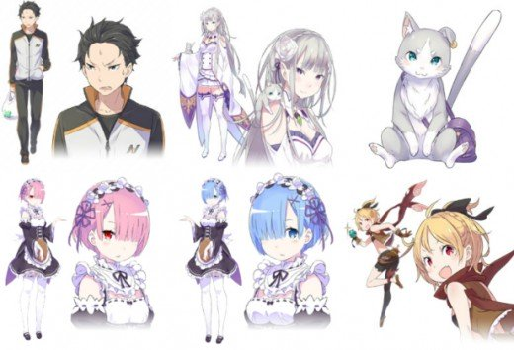

* **Subaru Natsuki**: Main character. A hikikkomori from our world, he is transported to the kingdom of Lugunica for unknown reasons, where he is soon caught up in local politics and events surrounding Emilia.
* **Emilia**: Initially introduces herself as Satella, but in later timelines hates to be compared to the legendary silver-haired half-elf witch she resembles. Emilia is one candidate to be the next ruler of Lugunica, but shows no real interest in politics. People hate her for being a half-elf and physically resembling the legendary witch Satella. Whether she has more of a connection to, or is, Satella is unclear.
* **Rom**: The old man, a giant, who takes care of Felt and runs a bar.
* **Felt**: A speedy blonde girl, the thief who initially stole Emilia's insignia. She becomes a candidate to be the next ruler of the kingdom because Emilia's insignia magically reacted with her. It's possible that Felt is related to the royal family, but that can't be determined, and they are deceased.
* **Ram and Rem**: These maids are not the innocent "maid café" maids you see in most anime. They're warriors there to protect Emilia, who they defend with absolute loyalty. But do they have ulterior motives for helping her?
* **Puck**: A spirit animal in the form of a cat who acts as a guide, friend, confidant, and helper for Emilia. I thought it was female because of its voice, but apparently is referred to as a male by other characters. I just didn't pick up on this. It seems to be protective of Emilia like a parental figure. You won't like him when he's angry.
* **Beatrice**: A peculiar servant of Emilia's, Beatrice is a mage who rules a bizarre library that seems to have strange magical laws governing it. She cannot leave Emilia's mansion. Sō kashira.
* **Priscilla**: The bitchiest bitch that ever bitched. She's a royal brat and a candidate to be the 42nd King of Lugunica, and she wants nothing more than the power the throne will give her.
* **Anastasia**: Although she has the appearance of a cute little girl, Anastasia is a cunning leader in trade, and another candidate for King, who hopes to use her expertise in business to benefit the people of the kingdom.
* **Crusch**: A tough warrior woman, able to detect when someone is lying. She has zero tolerance for nonsense. As another candidate for King, she hopes to move the country forward and weed out corruption.
* **Wilhelm**: Crusch's butler, an older gentleman. One of the most skilled swordsman, as a formal member of the Royal Guard. Holds a grudge against the white whale for the death of his wife.
* **Reinhardt**: One of the most powerful people in this world, a Royal Guard knight and "sword saint". He ends up supporting Felt. Wilhelm is his grandfather.
* **Julius**: Anastasia's knight, who initially looks down on Subaru, but gradually gains respect for him.
* **Felix**: Crusch's knight, a healer who refuses to use a sword. Has a feminine appearance and manner of dress, but is male.
* **Elsa**: Not at all like the Disney one, this Elsa can sense fear and has a fetish for disemboweling people. Why was she after Emilia's insignia? We might never get to the bottom of it.

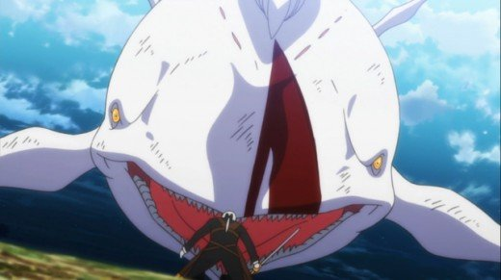

## Themes and Symbols:

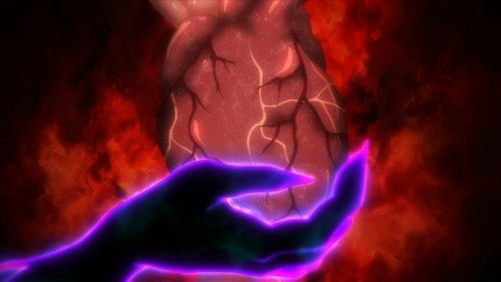

Review: Interestingly enough, a white whale is mentioned in the second half of the first episode, as part of Felt's pass code to get into Rom's house. Later, Subaru and a team of badass characters has to fight a white whale, that flies, and has the power to erase memories of people it kills with its magical fog breath. Scary. But the idea comes from the novel *Moby Dick,* and the symbolism of that whale has been interpreted as many things. But mainly, the whale stood in for one man's descent into madness and how the lust for revenge can eat at a person. How does this concept translate into *Re:Zero?* Honestly, I'm not entirely sure. Is it Subaru's obsessive determination to become good enough for and save Emilia? Does it represent Rem having to overcome her own hostility and traumatic past experiences? It's one of the scariest monsters in anime, because it can not only kill people, but erase them forever. In that way, it's like an antithesis for Subaru, who can never really die, and retains memories of alternate futures, as the whale erases memories that do exist.

The seven deadly sins show up with connection to a cult worshiping Satella, who represents jealousy. Her nickname is "the jealous witch". But that's another bit of potential symbolism that remains unclear. Who was she jealous of? How did she get that name? So little is known about Satella and so little is revealed even by the end of the series.

So, yeah, there is potential symbolism in this show, but even I can't wrap my head around what it could possibly mean. Maybe if there is a second season, or if I read the light novels, I could say more about it. Or, maybe if I watch the show a second time, I'll figure out the hints and clues. Until then, I'm afraid all I can say is, huh?

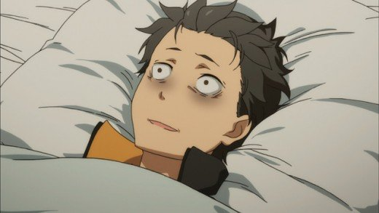

One main problem is, although the ending does a lot to wrap up the last story arc, there's a lot of unresolved questions that remain by the end of the anime. For example, we never learn if Emilia has any connection to the fabled witch Satella. Did she say that was her name as a joke, or was she being sincere? Are the witch and nice girl one person with two personalities? Is the witch actually a nice girl, who is just misunderstood and misrepresented by hearsay, like Elphaba in *Wicked?*The series does not tell us, but it may in a second season.

A problem is that this narrative's second half builds up more relationship cohesion between Rem and Subaru, while Emilia is out of the picture. But then, the ending makes it seem like Emilia was Subaru's true love all along, making Rem one of the most sadly friend-zoned characters in anime history. There's barely any interaction between Emilia and Subaru, and he spends all this time having amazing, heart-wrenching, epic adventures with Rem, and then the finale reunites Emilia and Subaru like a child pushing two dolls together and making kissy noises. It feels forced, and it felt less meaningful than Subaru's initial encounters with Emilia.

But what's great about this series? Subversion of almost every known anime character trope, for one. A lot of times, "deconstruction" is a term thrown around, but this could be said to be a deconstruction of epic fantasy anime and video games, done well. But it's not just into deconstructing and saying everything is awful in the way that say, *Neon Genesis Evangelion*did with giant robot anime. No, this is subtler. It blurs the line between the expectations the audience has of epic fantasy and a dark, grisly horror series, so that you kind of get the best parts of both. It's expanding, exploring, experimenting with the potential of its genre. You can't take anything for granted, and definitely don't know what to expect. You see things you've seen a million times before, but not how you've ever seen them. This series proves that originality is not the absence of clichés, it is the use of clichés in new ways.